SPECIES | Number
Snow Goose
Ross's Goose
Cackling Goose
Canada Goose
Brant Goose
Tundra Swan
Gadwall
American Wigeon
American Black Duck
Mallard
Blue-winged Teal
Northern Shoveler
Northern Pintail
Green-winged Teal
Canvasback
Redhead
Ring-necked Duck
Greater Scaup
Lesser Scaup
Bufflehead
Common Goldeneye
Common Eider
King Eider
Black Scoter
White-winged Scoter
Surf Scoter
Harlequin Duck
Long-tailed Duck
Hooded Merganser
Common Merganser
Red-breasted Merganser
Spruce Grouse
Rock Ptarmigan
Willow Ptarmigan
Common Loon
Pacific Loon
Red-throated Loon
Horned Grebe
American Bittern
Least Bittern
Great Blue Heron
Osprey
Northern Harrier
Golden Eagle
Bald Eagle
Red-tailed Hawk
Rough-legged Hawk
Yellow Rail
Sora
American Coot
Sandhill Crane
Black-bellied Plover
American Golden-Plover
Semipalmated Plover
Killdeer
Spotted Sandpiper
Solitary Sandpiper
Greater Yellowlegs
Lesser Yellowlegs
Whimbrel
Hudsonian Godwit
Ruddy Turnstone
Red Knot
Stilt Sandpiper
Sanderling
Dunlin
Baird's Sandpiper
Least Sandpiper
White-rumped Sandpiper
Buff-breasted Sandpiper
Pectoral Sandpiper
Semipalmated Sandpiper
Short-billed Dowitcher
Wilson's Snipe
Wilson's Phalarope
Red-necked Phalarope
Red Phalarope
Pomarine Jaegar
Parasitic Jaeger
Long-tailed Jaegar
Bonaparte's Gull
Little Gull
Ross’s Gull
Ring-billed Gull
Herring Gull
Glaucous Gull
Iceland Gull
Thayer’s Gull
Sabine’s Gull
Ivory Gull
Black Tern
Common Tern
Arctic Tern
Black Guillemot
Short-eared Owl
Long-eared Owl
Great Horned Owl
Barred Owl
Great Grey Owl
Snowy Owl
Northern Hawk Owl
Boreal Owl
Northern Flicker
Three-toed Woodpecker
Black-backed Woodpecker
American Kestrel
Merlin
Peregrine Falcon
Gyrfalcon
Yellow-bellied Flycatcher
Alder Flycatcher
Gray Jay
American Crow
Common Raven
Horned Lark
Tree Swallow
Bank Swallow
Barn Swallow
Cliff Swallow
Boreal Chickadee
Ruby-crowned Kinglet
Gray-cheeked Thrush
Swainson's Thrush
American Robin
Northern Shrike
Brown Thrasher
American Pipit
European Starling
Bohemian Waxwing
Lapland Longspur
Smith’s Longspur
Northern Waterthrush
Tennessee Warbler
Orange-crowned Warbler
Common Yellowthroat
Yellow Warbler
Blackpoll Warbler
Palm Warbler
Yellow-rumped Warbler
Wilson's Warbler
American Tree Sparrow
Savannah Sparrow
Nelson's Sparrow
Fox Sparrow
Song Sparrow
Lincoln's Sparrow
White-throated Sparrow
Harris's Sparrow
White-crowned Sparrow
Dark-eyed Junco
Red-winged Blackbird
Yellow-headed Blackbird
Rusty Blackbird
Common Grackle
Brown-headed Cowbird
Snow Bunting
White-winged Crossbill
Pine Grosbeak
Common Redpoll
Hoary Redpoll
House Sparrow
Name of IBA:
Your Name:
Contact Info: 
Assistant names: 
Date of Survey:  Time: Start:  Finish: 

Thank you for donating your time to help monitor and safeguard IBAs in Manitoba. Your work is a significant contribution to conservation in this province.
The Manitoba IBA Program is a partnership of:

Please submit your forms to:
Manitoba Important Bird Areas Program
Nature Manitoba
401 – 63 Albert Street
Winnipeg, MB R3B 1G4
iba@naturemanitoba.ca
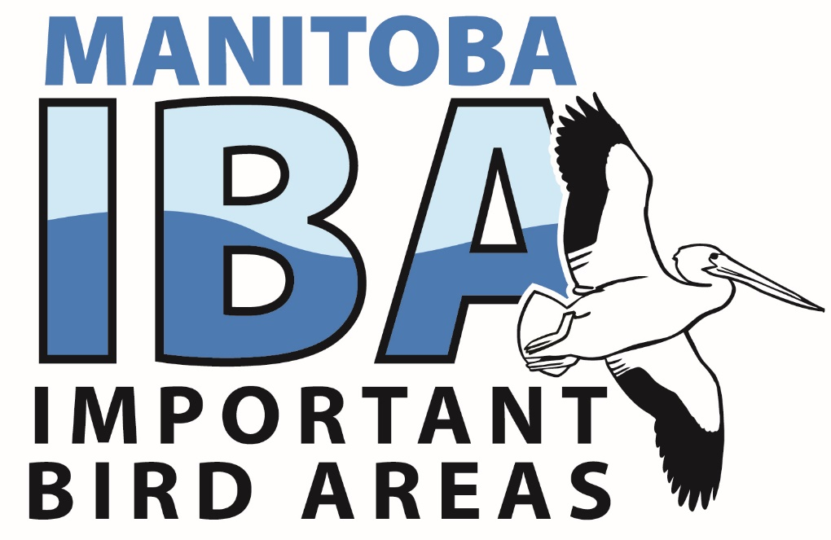
IBA Daily Monitoring Checklist
Hudson Bay IBA’s
Checklist for:
MB003-Churchill & Vicinity
MB006-Kaskattama River Mouth
MB008-Nelson River Estuary & Marshy Point
MB013-Seal Bay Estuary

For detailed maps of IBA boundaries see http://www.ibacanada.ca/ or contact the Manitoba IBA Program Coordinator (see end of document for details).

