Using www.ebird.ca for the Manitoba Important Bird Area program

Ebird (www.ebird.ca) has been chosen as the database of the IBA program across Canada. All IBA monitoring data must now be entered into ebird. We can help you with this if you don’t use ebird but we greatly appreciate it if you enter all your own data. This is not only a great way to contribute data; it is also a fun way to keep track of your own sightings. To start with, you will need to register to create your own unique user id. We can help you get familiar with the webpage, which is quick and easy to learn to use.

The key points to remember about using ebird for IBA monitoring are:
- Make checklists for small areas, e.g. 3 different checklists for different parts of the IBA are much better than one big checklist. The Manitoba IBA Program will provide maps on our website for each IBA which will highlight unique checklist areas for eBird entry.
- Use www.ebird.ca (instead of the .com option) and select the “IBA Canada” protocol under the “Other” Observation types
- Please enter every bird and every visit to an IBA (or give us one data form per visit so we can enter it for you)

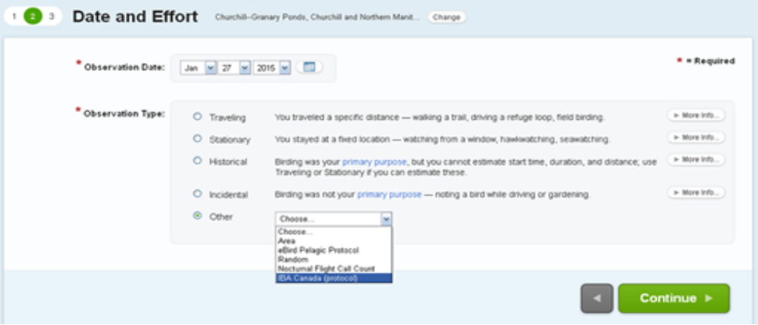
Selecting the “IBA Canada” protocol under the “Other” Observation types is very useful. This method enables automated (behind the scenes) summing of totals seen in different parts of the IBA on the same day and may be used to update the summary tables on the IBA webpage.

Using several small checklists enables us to compare different counts in different parts of the IBA. The more location-specific the data are, the more useful they are!

In addition, you can explore species lists and bar charts for all IBAs using the “Explore Data” tab in ebird.

If you have any further questions, or wish for some help with eBird, please contact the IBA Coordinator at iba@naturemanitoba.ca or (204)-943-9029.

